**West Bengal**

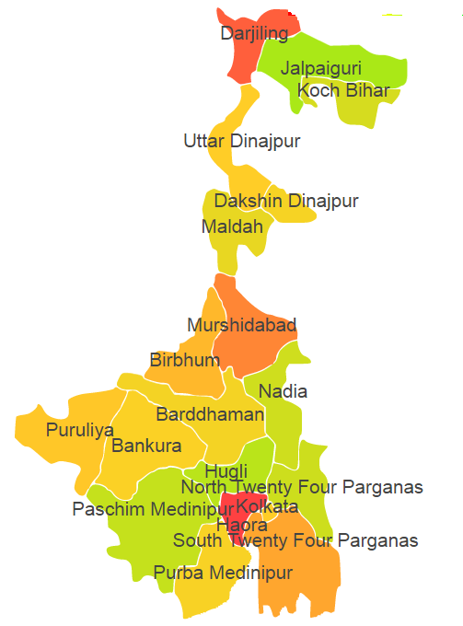

West Bengal comprises of four Agro Ecological Regions (AER) 12,15,16 & 18.

**Agro-Eco Region 12:** AER 12 in West Bengal comprises of Bankura, Bardaman, Birhum, Pashchim Medinipur and Puruliya districts of Eastern (Chhotanagpnr) Plateau and Eastern Ghats under Agro Ecological Sub Region (AESR) 12.3.

**Agro-Eco Region 15:** AER 15 in West Bengal comprises of Bankura, Bardaman, Birhum, Dakshin Dinajpur, Haora, Hugli, Jalpaiguri, Malda, Mursidabad, Nadia, North 24 Pragana, Pashchim Medinipur, Kochbihar, South 24 Parganas and Uttar_Dinajpur districts of Bengal and Assam Plain under Agro Ecological Sub Regions (AESR) 15.1 & 15.3.

**Agro-Eco Region 16:** AER 16 in West Bengal comprises of only one Darjeeling district of Eastern Himalayas under Agro Ecological Sub Region (AESR) 16.2.

**Agro-Eco Region 18:** AER 18 in West Bengal comprises of East mednipur and South 24 Parganas districts of Eastern Coastal Plain under Agro Ecological Sub Region (AESR) 18.5.